SDG 6 - TARGETS 6.1 (Safe Drinking Water For All) & 6.2 (Sanitation For All)

BACKGROUND
During 2015, South Africa presented its final report on the state of the progress the country has made in rolling back poverty in all its forms, as agreed upon globally and initiated in 2000, called the Millennium Development Goals (MDGs). This 15-year process covered the tracking of eradication of poverty in a number of dimensions, measured across 8 basic areas or goals. Since then the global community has adopted a further set of development issues to continue and expand the work of the MDGs. This set of aspirations is termed the Sustainable Development Goals (SDGs) and will come to fruition in 2030. The SDGs are both an extension and an expansion of the work done under the MDGs; in particular, the number of goals increased from 8 to 17, the number of targets increased from 20 to 169 and the indicator suite increased from 60 to 230.
What we have found from our experience in populating the indicator for SDG 6 is the essential difference between the MDG and SDG indicators is that of method of implementation. During the MDG process South Africa developed its skills in indicator development and putting in systems to monitor and evaluate. What the SDGs in bringing to the mix is that of method of implementation where the Target and its accompanying Indicator at times seems to be mutually exclusive. This requires that the target needs to be understood to understand the linkages it has with the indicator and invariably its linkage can be found in the method of implementation. This is particularly true in the case of indicator 6a.
The water and sanitation indicators which have been overseen by the JMP from the MDG process through to the SDG have evolved to include a global monitoring ladder. JMP have recently updated their www.washdata.org site and updated the MDG indicators South Africa presented in their MDG report. Using the new water and sanitation ladder they presented that information according to the SDG ladder as set out below:
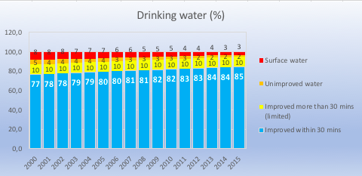
The MDG indicator for access to an improve water source is the SDG indicators of basic and limited (summation). During the 15 year period basic (improved within 30 min) access to water improved by 8% and no access together with unimproved access improved by 8%. Limited access; yellow in above chart (i.e. access to a tap but greater than 200 meters from the place of residence) remained constant during the period under review.
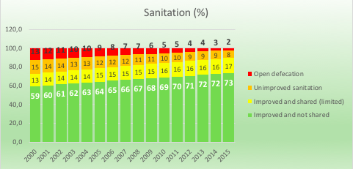
Sanitation has shown good access to basic sanitation growing by 14% over 15 years. Of interest is the growth in how much the access to improved sanitation has grown from 13% in 2000 to 17% in 2015. This is evidence of the urbanisation rate that has taken place over the last 15 years in South Africa. Of tremendous interest at the latest AfricaSan meeting in South Africa at the end of September 2018, was AMCOW’s country members asking how South Africa achieved a reduction in defecation from 13% to 2%.

TARGET 6.1: By 2030, achieve universal and equitable access to safe and affordable drinking water for all

INDICATOR 6.1.1: Percentage of population using safely managed drinking water services

Indicator definition and method of computation (MoC)
DEFINITION: Population using an improved drinking water source (piped water into dwellings, yards or plots; public taps or standpipes; boreholes or tubewells; protected dug wells; or protected springs and rainwater) that is located on premises and available when needed and which is free from faecal and priority chemical contamination. | MoC: Percentage of population using an improved basic drinking water source (piped water into dwellings, yard or plot, public taps or standpipes, boreholes or tubewells, protected dug wells, protected springs and rainwater) divided by the total population multiplied by 100.
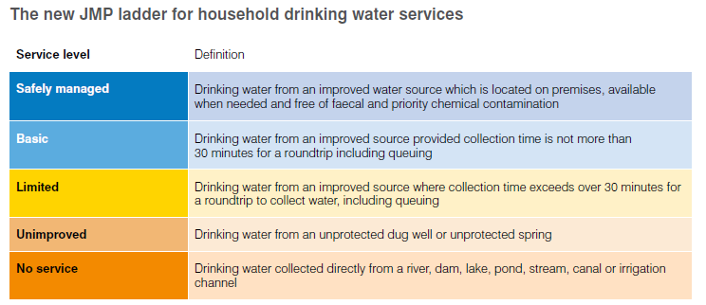

JMP WATER LADDER - SDG ACCESS TO BASIC SERVICE 84%
BASE YEAR = 2015: Source Data Stats SA GHS
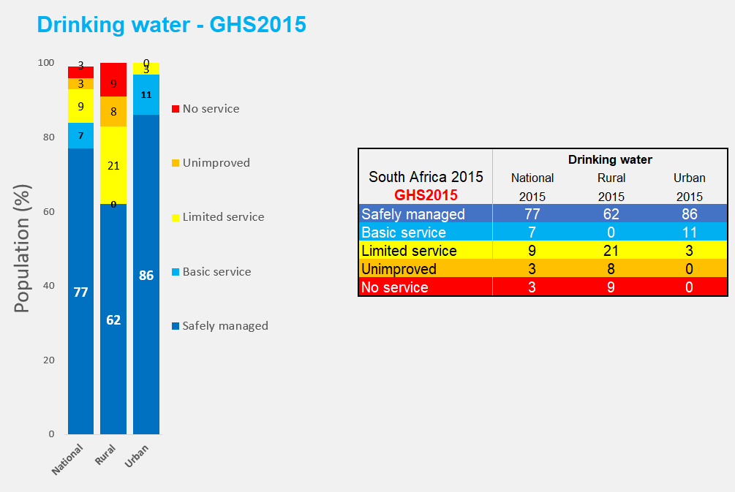
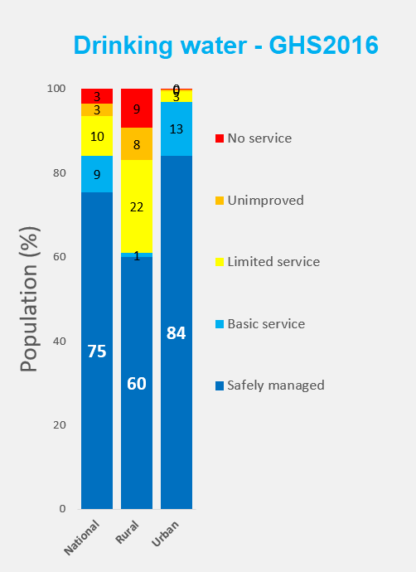 | 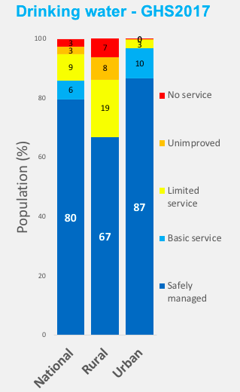
From the graphical view above the access to basic water supply (i.e.access to an improved water source within 200 meters of the household) is determined by adding safely managed (in 2015 = 77%) to the portion showing/remaining of basic supply (in 2015 = 7%) to give you a value of basic water supply which equates to 84% in 2015. The definition for the Millennium Development Goals (MDG) for access to improved water source aligns with the SDG definition when its components of “basic supply” (access to an improved water source is less than 200m) is added to “limited supply” (access to an improved water source greater than 200m), which in 2015 equates to 93% (i.e. =(77+7)+9).
Basic water supply improved from 84% in 2015 to 86% in 2017 according to the General Household Survey of Stats SA. From the graphs it can be seen that the limited service which are taps located at a distance greater than 200 meters from the house have been upgraded to basic service while the unimproved and no service categories have seen no improvement in services.

TARGET 6.2: By 2030, achieve access to adequate and equitable sanitation and hygiene for all and end open defecation, paying special attention to the needs of women and girls and those in vulnerable situations

INDICATOR 6.1.1: Percentage of population using safely managed sanitation services, including a hand-washing facility with soap and water
Indicator definition and method of computation (MoC)
DEFINITION: The percentage of population using safely managed sanitation services, including a hand- washing facility with soap and water is currently being measured by the proportion of the population using an improved basic sanitation facility at the household level which is not shared with other households and where excreta is safely disposed in situ or treated off-site. ‘Improved’ source defined the same as used for MDG monitoring i.e. flush or pour flush toilets to sewer systems, septic tanks or pit latrines, ventilated improved pit latrines, pit latrines with a slab, and composting toilets. | MoC: The total number of population using improved sanitation (flush or pour flush toilets to sewer systems, septic tanks or pit latrines, ventilated improved pit latrines, pit latrines with a slab, and composting toilets) divided by the total population multiplied by 100.

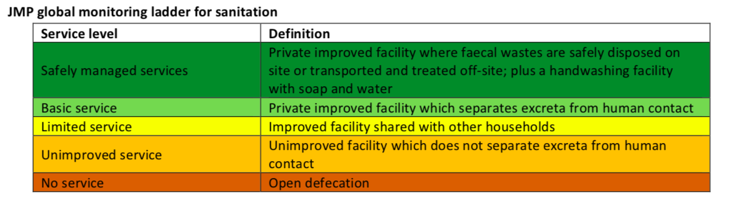

JMP SANITATION LADDER - SDG ACCESS TO BASIC SERVICE 80%
BASE YEAR = 2015 : Source Data Stats SA GHS

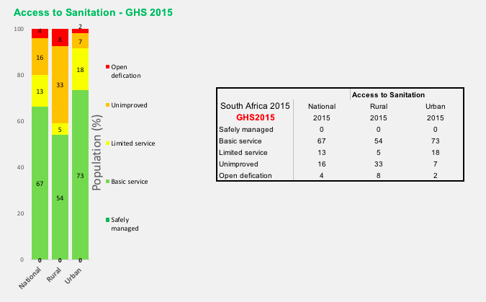
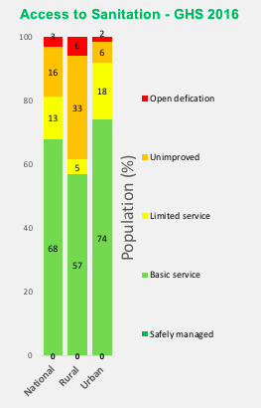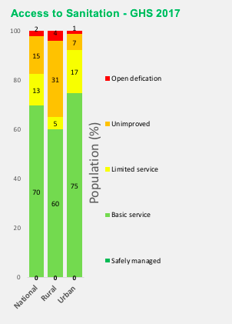
South Africa has shown good progress in improving access to sanitation whereby in 2017 access to improved sanitation was 83% which means a remaining target of growth of 17% over the next 13 years is needed. This will require those servicing the municipal environment to review their policies and approaches to reduce the high number of households sharing; limited at 17%. Much of this is due to rapid urbanisation which needs to be addressed in many aspects.The unimproved sanitation access, i.e. sanitation backlogs in rural areas, is receiving special attention under the guidance of an Inter-Ministerial Task Team.
As open defecation is receiving much attention, an additional question was asked in the household survey of Stats SA GHS 2017 and its outcomes are shown below:

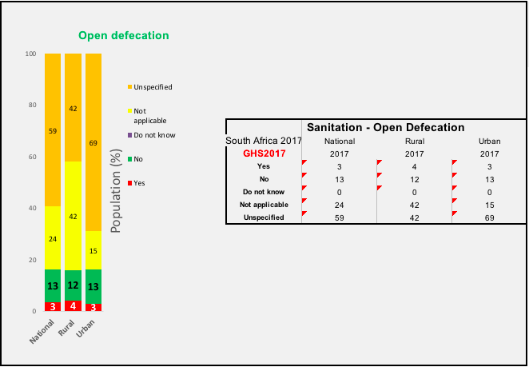
Hygiene has been added to the SDG targets for sanitation and in 2016 discussions were held with Stats SA to include questions in the GHS. Recently in 2018, the results of GHS 2017 were released and the questions have been analysed and the results of the outcomes are shared below:

JMP ladder for hygiene:
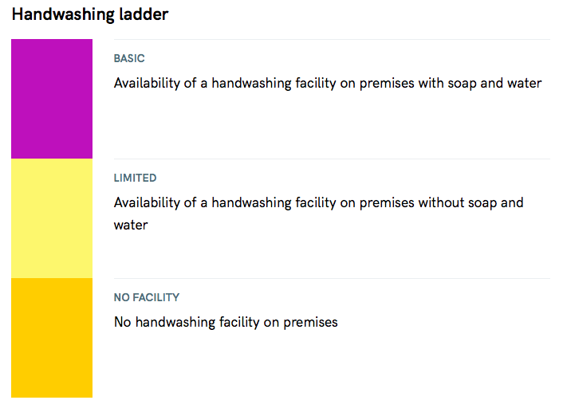

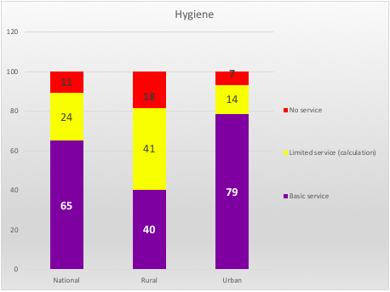
The above results are very recent and need to be shared and discussed with the sector. The indicator for limited service was not clear from the indicator but easily derived from the number of questions posed around hand washing habits in the GHS questionnaire.

